# Intelligent and persolized system for remote healthcare and wellness

## Introduction

Translational medicine is stepping in personalized healthcare systems, especially for elderly people, where preventive tools can noticeably improve the life style and therefore, increase the lifetime. Cardiovascular disease, as the first factor of human mortality, is regarded as one of the major group of progressive disease in which timely screening, together with the personalized monitoring of the underlying disease can play important roles in finding appropriate patient management. The asymptomatic phase of such diseases can be prolonged for several years, and the suffering patients are often unaware of the disease progresses. Importance of the patient monitoring is better understood if considering that the average lifetime of the patients with the valvular obstructive disease can be as short as two years after manifestation of the physical symptoms, if the patient remains untreated. It is therefore of vital importance to screen and monitor such the patients, sufficiently soon, when effective therapeutic procedure can drastically improve the lifetime. Such the degenerative process can be appeared in respiratory system, lever and neural system are other examples of the human organs that are often at the risk of degeneration in elderly people. It is important to note that trend of the degeneration as well as the extent to which a disease appears, varies from person to person, depending the background of the person in sense of the both genetic and habitual conditions, which necessitate a personalized care for an optimal management. Translational medicine has initiated new technologies to improve life quality in terms of the health and wellness. Recent advances in machine learning and data mining in conjunction with the modern telecommunication facilities, make a personalized care possible, especially for the retired people where reduced activity is majorly seen. This project proposes a distributed system for a broad range of the people to measure and monitor health condition as well as suggesting structures activities to enhance wealth level of the individuals based on the background and current conditions. The main focus of the project is on elderly people, or the retired people, who are at the risk of body degeneration and progressive disease.

## The system

The proposed system is a cloud-based solution to measure a number of the vital and health-related parameters from the patients, and compare them to the previously measured ones both from the same patients and also from a population of healthy one, to quantitate the level of the health. Structure of the system is depicted in Figure 1:

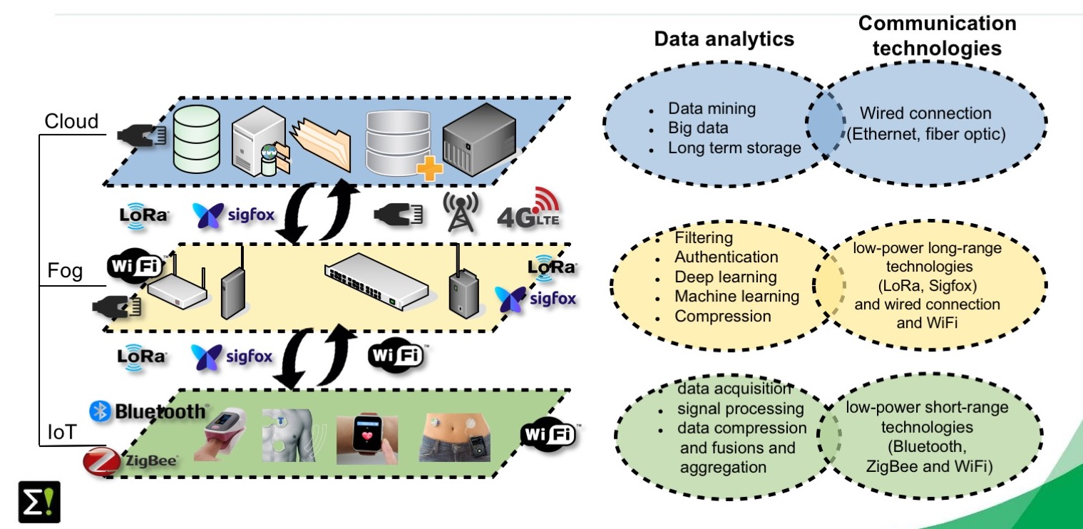

Figure 1 Structure of the system

The system contains several sensors to measure vital signals, including electrocardiogram, respiratory CO2 level, the saturated blood oxygen, blood glucose, gyroscope, accelerometer, blood pressure, temperature. Not all the sensors are used for all the individuals, instead, a healthcare provider can customize the sensors according to the physical condition of the individuals. The system has the possibility to prescribe an activity plan and the related parameters are measured in the fog layer through the wireless communication network. The processor at the fog layer receives the signals from the sensors as well as the health related parameters from the patient history at the cloud, and dynamically modifies the activity plan, provides a short report of the health condition or recommends to be visited by a doctor using advanced machine learning and data mining methods. This processor performs a level of the intelligent processing based on our innovative artificial intelligent-based methods, for data redundancy, and also models the health condition of the individual based on the pervious history and current condition of the individual. These quantitative parameters can be used for wellness purposes, and sometimes for the healthcare situations in which patient monitoring is necessarily administered. Moreover, it can automatically send appropriate alarms to the responsible persons or authorities in case of the need to an emergency action. Figure 2 illustrate a typical application of the system.

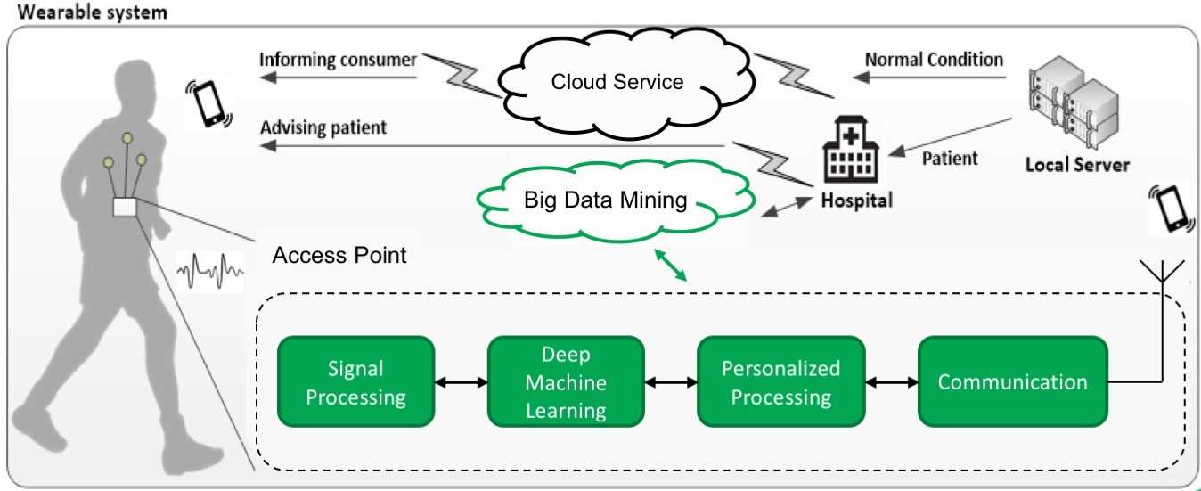

Figure 2 Layout of the system

## The user groups

The system provides the unique feature of taking background and previous condition of the patients into account by employing our dynamic models for the physiological activities. The history of the patients is also considered in finding optimal activity plan using our innovative data mining methods. These allow the system to cover a broad range of the users including healthy people with reduced activity to the patients with sever cardiac disease. Examples of the users groups are listed as follows:

* Patients with diabetes
* Patients with progressive heart diseases
* Lung disease e.g. COPD
* Elderly people
* Healthy people with reduced activity
* Etc.